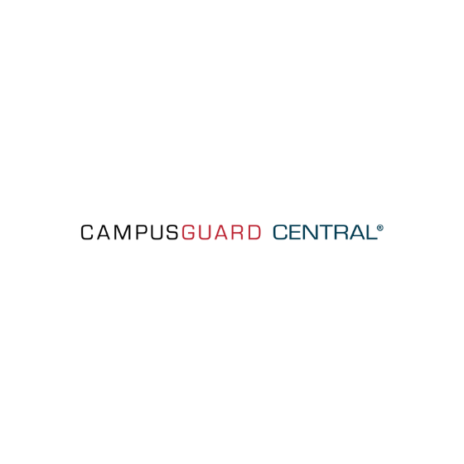
Introducing the New, Enhanced CampusGuard Central

LINCOLN, NEBRASKA—CampusGuard, a full-service cybersecurity and compliance services firm, is excited to announce the latest release of CampusGuard Central®, its dynamic customer compliance portal. CampusGuard Central empowers organizations to manage PCI DSS compliance across their enterprise with a single, user-friendly tool.

Central’s latest release includes the following enhancements:

- Updated user interface:
  - Hide or expand the left navigation bar
  - Collapsible group headers on the dashboard
  - Expand the view to full-screen
  - Resize and/or filter data tables
- Full support for PCI DSS v4.0
- Customers can define an unlimited number of Custom Fields
- Centralized button hub for quick access to common functions
- Two-factor authentication via email or mobile
- SAQ summaries (aka Rollups) now have their own section
- The application returns the user to where they left off within their incomplete SAQ
- Ability to upload multiple documents into the Document Locker at the same time

“Our customers are our greatest source of feedback and inspiration; we listen to them,” said Judi Seguy, Director of Operations. “Since our major update in 2023, the Development Team has worked especially hard to deliver major infrastructure upgrades to Central, bringing noticeable performance boosts and an updated, more intuitive user interface. We're thrilled to share these upgrades with you, and we think you'll love the enhanced experience.”

CampusGuard Central simplifies managing your PCI DSS compliance status and empowers your organization to strategize and prioritize the next steps for achieving and maintaining compliance. Explore how CampusGuard Central can streamline your PCI DSS compliance management process.

About CampusGuard
Founded in 2009, CampusGuard provides cybersecurity and compliance services for complex organizations, including higher education, healthcare, state and local government and agencies, financial services firms, and SaaS/tech companies, among others. CampusGuard’s success in serving their customers can be attributed to the experience, education, and commitment of their certified professionals and their in-depth understanding of the unique needs of the markets they serve. For more information visit www.campusguard.com.

